NAME: | Ameya Dabholkar
UID: | 2021300023
SUBJECT | Design and Analysis of Algorithm
EXPERIMENT NO : | 03
DATE OF PERFORMANCE | 27/02/2023
DATE OF SUBMISSION | 6/03/2023
AIM: | To multiply two matrices using strassen’s matrix multiplication.
PROBLEM STATEMENT 1: | Strassen’s matrix multiplication on a generalized 2x2 matix.
ALGORITHM and THEORY: | In this context, using Strassen’s Matrix multiplication algorithm, the time consumption can be improved a little bit.  Strassen’s Matrix multiplication can be performed only  on square matrices where n is a power of 2. Order of both of the matrices are n × n.  Divide X, Y and Z into four (n/2)×(n/2) matrices as represented below −  Z=[IKJL]�=[����] X=[ACBD]�=[����] and Y=[EGFH]�= [����]  Using Strassen’s Algorithm compute the following −  M2:=(B+D)×(G+H)�2:=(�+�)×(�+�)  M3:=(A−D)×(E+H)�3:=(�−�)×(�+�)

M4:=A×(F−H)�4:=�×(�−�) M5:=(C+D)×(E)�5:=(�+�)×(�)
M6:=(A+B)×(H)�6:=(�+�)×(�) M7:=D×(G−E)�7:=�×(�−�)
Then,
I:=M2+M3−M6−M7�:=�2+�3−�6−�7 J:=M4+M6�:=�4+�6 K:=M5+M7�:=�5+�7 L:=M1−M3−M4−M5
Analysis
T(n)={c7xT(n2)+dxn2ifn=1otherwise�(�)={����=17��(�2)+
���2��ℎ������ where c and d are constants
Using this recurrence relation, we get T(n)=O(nlog7)�(�)=�(����7).

Hence, the complexity of Strassen’s matrix multiplication algorithm is O(nlog7)�(����7).
PROGRAM: | #include<stdio.h> #include<time.h> void main()  {  int a[2][2],b[2][2],c[2][2],i,j;  int p[7];  int s[10];  clock_t start,end;  printf("Enter the elements of 1st matrix:"); for(i=0;i<2;i++)  {  for(j=0;j<2;j++)  {  scanf("%d",&a[i][j]);  }  }  printf("Enter the elements of 2nd matrix:");

for(i=0;i<2;i++)
{
for(j=0;j<2;j++)
{
scanf("%d",&b[i][j]);
}
}
start=clock(); s[0]=b[0][1]-b[1][1];
s[1]=a[0][0]+a[0][1];
s[2]=a[1][0]+a[1][1];
s[3]=b[1][0]-b[0][0];
s[4]=a[0][0]+a[1][1];
s[5]=b[0][0]+b[1][1];
s[6]=a[0][1]-a[1][1];
s[7]=b[1][0]+b[1][1];
s[8]=a[0][0]-a[1][0];
s[9]=b[0][0]+b[0][1];

p[0]=s[0]*a[0][0];
p[1]=s[1]*b[1][1];
p[2]=s[2]*b[0][0];
p[3]=s[3]*a[1][1];
p[4]=s[4]*s[5];
p[5]=s[6]*s[7];
p[6]=s[8]*s[9];

c[0][0]=p[4]+p[3]-p[1]+p[5]; c[0][1]=p[0]+p[1];
c[1][0]=p[2]+p[3]; c[1][1]=p[4]+p[0]-p[2]-p[6];

for(i=0;i<10;i++)
{

printf("\nS%d=%d ",i+1,s[i]);
}
printf("\n"); for(j=0;j<7;j++)
{
printf("\np%d=%d ",j+1,p[j]);
}
printf("\n\n");
printf("MATRIX A:-\n"); for(i=0;i<2;i++)
{
printf("\n"); for(j=0;j<2;j++)
{
printf("%d\t",a[i][j]);
}
}
printf("\n");
printf("MATRIX B:-\n"); for(i=0;i<2;i++)
{
printf("\n"); for(j=0;j<2;j++)
{
printf("%d\t",b[i][j]);
}
}
printf("\n"); printf("MATRIX C:-\n\n");
printf("%d\t%d\n%d\t%d\n",c[0][0],c[0][1],c[1][0],c[1][1]); end=clock();
printf("The time taken by the program: "); printf("%lf",(double)(end-start)/CLOCKS_PER_SEC);
}

OUTPUT: | 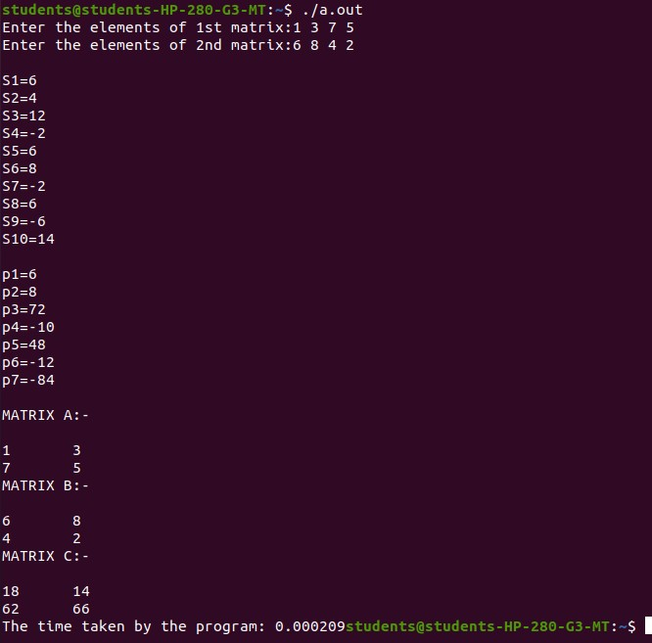
CONCLUSION: | By performing above experiment I have understood how the time complexity of strassen’s matix multiplication is better than that of normal mxn matrix multiplication.

